**STARAGILE DOCKER ASSIGNMENT -4**

1. **Create a Docker Volume:** create a Docker volume named **persistent_volume**:

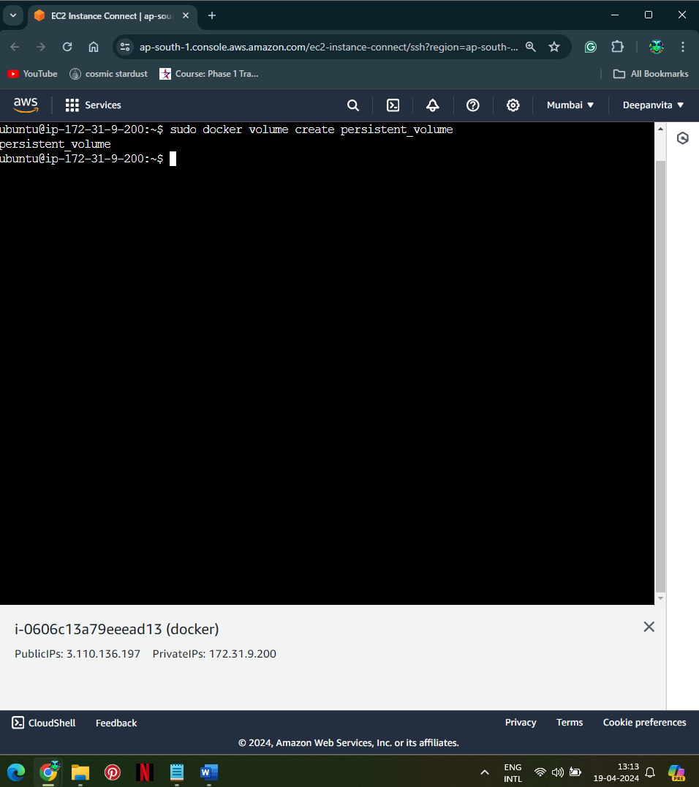

1. **Launch an Ubuntu container by mounting the created volume:** mount the volume **persistent_volume** to the directory **/data** inside the container:

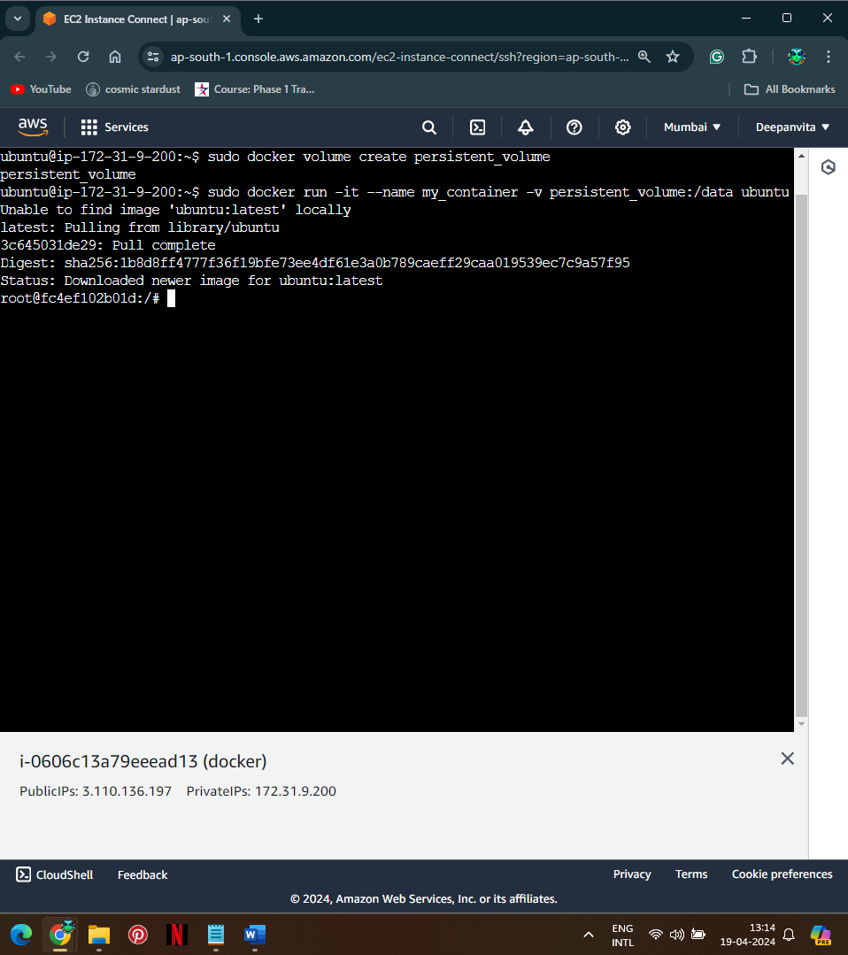

1. **Attach the terminal to the running Ubuntu container:** The container is already running with the **-it** option
2. **Create some dummy files into the persisted directory:** Inside the container's terminal, run the following commands to create some demo files:

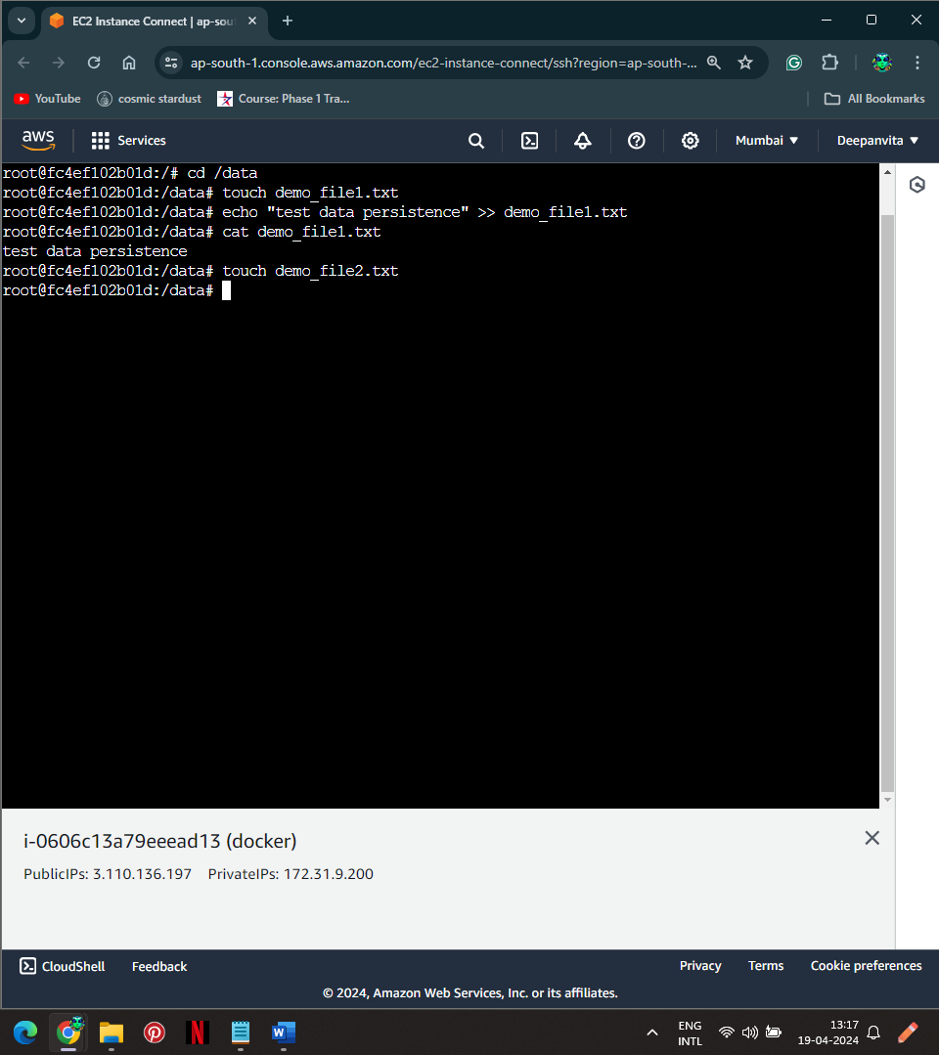

1. **Exit from the Container:** type **exit** in the terminal.
2. **Stop the container:**

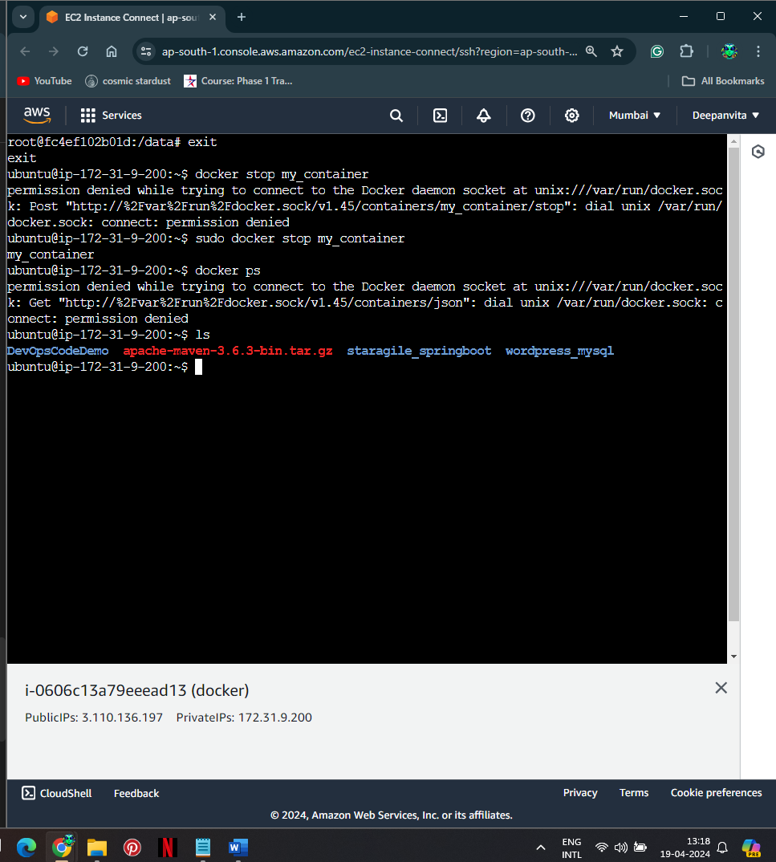

1. **Create a new container with the persistence volume.**
2. **Verify that the files created in the container are available in the Docker volume:** Once inside the new container, navigate to the **/data** directory and list the files using **ls**. see **demo_file1.txt** and **demo_file2.txt** there.

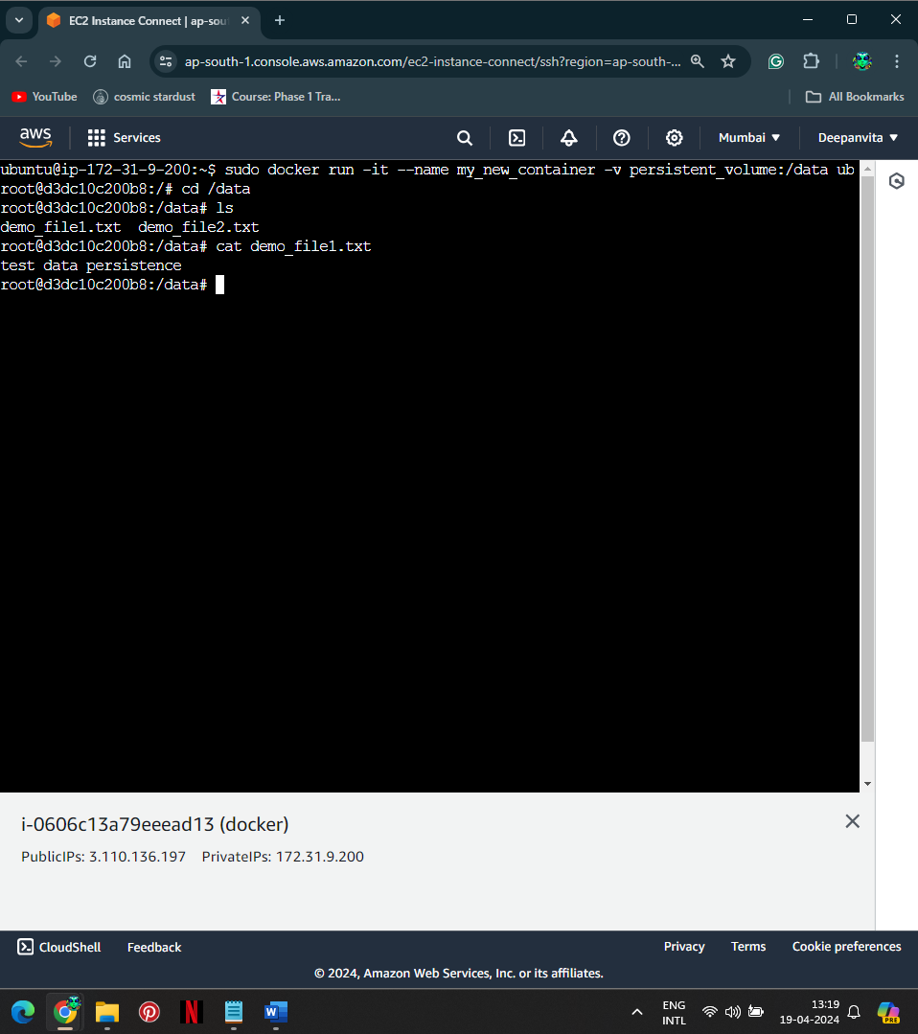

Done